Brandon Tarrash 7-6-21

Analyzing NHL Advanced Data

Throughout this post we will explore how these advanced NHL analytics may have an effect on a players, teams, as well as other stats. Specifically, we will look to answer: Does a player's ZSR have a major effect on his Corsi? As well as How important is “luck” in measuring a team’s success? Is PDO actually a good measure of “luck”? As we explored the data sets in order to try to answer these questions, we found some interesting results.

The first question we will be looking at is does a player's ZSR have a major effect on his Corsi? Often teams will look to a player’s Corsi to determine how the team is playing while he is on the ice. Many analysts claim that this is the single most important statistic in hockey and often urge general managers to build their teams around players with a high Corsi. However, there is not a lot of talk about how Corsi may be affected by other aspects of the game, in this case by ZSR. ZSR is a calculation of the percentage of times a player starts off in the offensive vs defensive zone after the whistle is blown and there is a faceoff. The more times you start off in the attacking side of the ice as opposed to being stuck in on the defending side, the higher a player’s ZSR will be. It is assumed you will take more shots and give up less when having a higher ZSR as you will spend more time attacking. We predicted that a player’s ZSR may have a noticeable effect on their Corsi. In order to take a look at this we graphed every player in the National Hockey League by ZSR and Corsi over the 12 seasons the Jamesartherus NHL Data set tracked, from 2007-2019. We saw that graphs from each year were very similar, so we decided to take a deeper dive on the 2018-19 season specifically. In this graph, we also color-coded each player by the four skater positions in hockey.

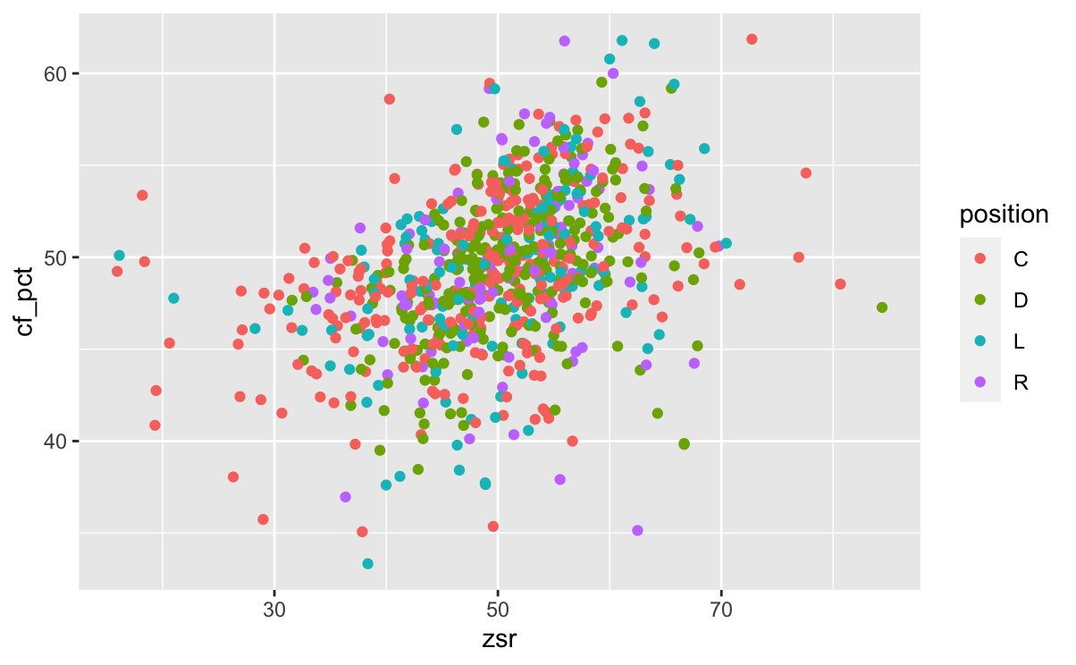

The graph indicates that there seems to be a clear positive correlation between the ZSR and Corsi of players in the National Hockey League. This is important to keep in mind when assessing the advanced stats of players and their importance to a team. When considering a player’s Corsi they should also look into the context of what that players ZSR is as compared to other players in the league.

Moving on to The PDO stat, we first want to see if PDO has a high correlation to a team’s success. It is hypothesized that in general a team that is very lucky throughout the season will achieve more regular season success. In order to track this we again looked into the 2018-19 season and graphed teams PDO to the amount of points they accumulated in the regular season as shown below.



As we hypothesized, there seems to be a pretty strong correlation to a teams overall PDO to how well they played in the regular season. However, we did not want to just take this PDO statistic in at face value. With a statistic like luck that is so random and hard to decipher from, we decided to dive into whether it is really possible to measure such a statistic. We hypothesized that if this PDO statistic really was able to measure “luck”, then teams PDO’s should be pretty scattered and random from year to year. In order to take a look at this, we measured every team’s PDO over the 12 year interval provided in the NHL Data package as shown below.



The data was a bit surprising to us. As some teams seem to have pretty scattered PDO’s, many teams seem to stay pretty consistent over a couple years span with having either good or bad luck. This led us to theorize that PDO may not be the best statistic in general. It seems that many of the teams who had dominant seasons seemed to have good luck, while the teams at the bottom of the standings had bad luck over many consecutive years. This leads us to believe that PDO may be a better statistic of which teams are better at creating higher quality and capitalizing on opportunities, than it is a true measure of luck. This is important to recognize as many fans and executives will claim teams they perceive as not very good are only at the top of the standings because they have a high PDO and hence are “getting lucky”, when the reality of the situation may be the opposite. The team’s PDO may be very high because they do in fact create top tier scoring chances and capitalize when they get them. This draws us to our conclusion that PDO may not be a great statistic in general because in a game like hockey, not all shots should be deemed the same.